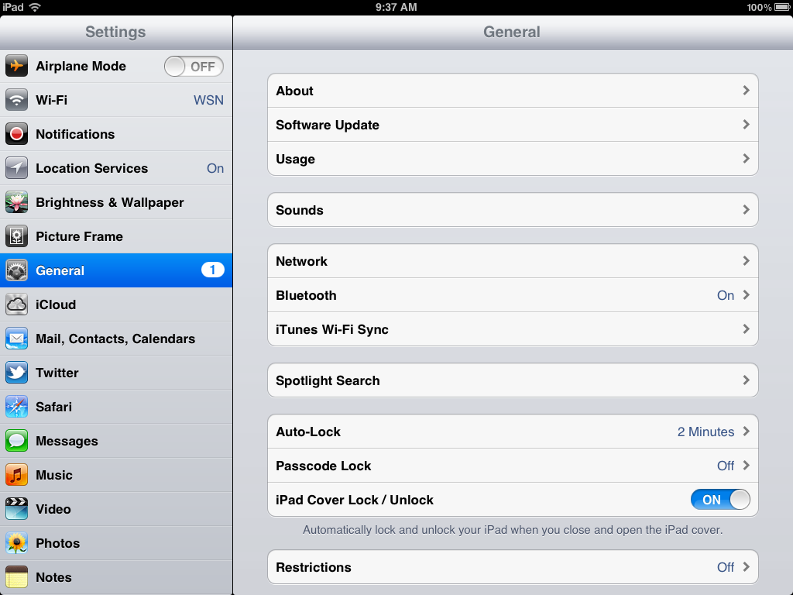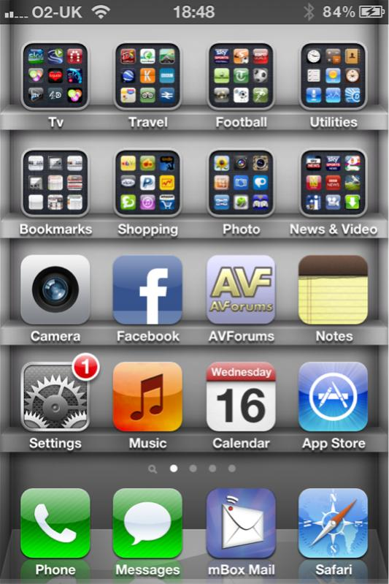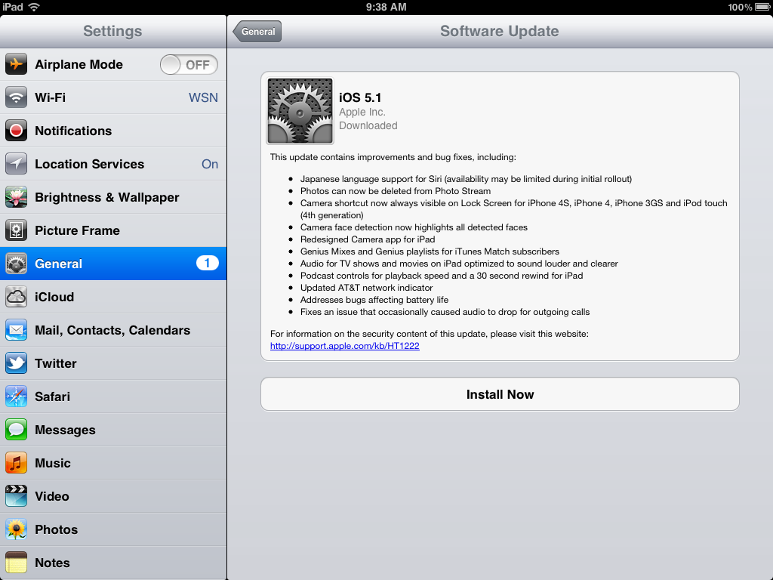

**PLEASE NOTE:**

It’s always a good idea to backup your device before installing any update!

**Updating Your iDevice**

3. Next click on Software Update

2. Click on the Settings icon and select General and you will see the screen below.

1. You may have noticed a little red 1 next to the Settings icon (with the gears) on your iPad, iPod, or iPhone. You are seeing this icon because your device has an update.

*Note: You won’t want to plan to use your device immediately as the update can take up to 20+ minutes.*

4. Click on Install Now and your device will begin updating. It will shutdown and restart and the update can take up to 20 minutes. *Note: you must have your device plugged in or you will not be able to install the update!*